Collect the default gateway from network and sharing center

wifi -> deatils

Rt click on wifi -> properties -> internet protocol v4

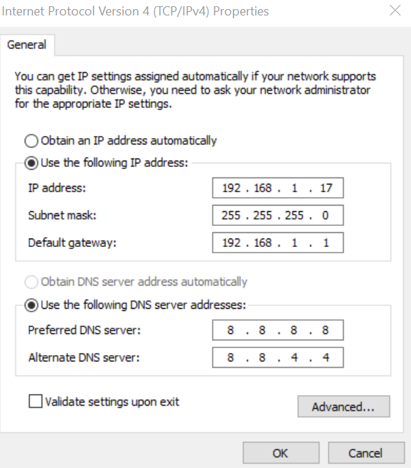

Now go to Virtual box -> settings ->network -> select adapter1-> bridge n/w -> advance -> promicious mode -> allow all

Adapter2 -> host only adapter -advanced -> allow vms

Adapter3 -> nat

Start device -> and make ip address static

#nmcli d

Go to path

#/etc/network

Vi /etc/sysconfig/network-scripts/ifcfg-enp0s3

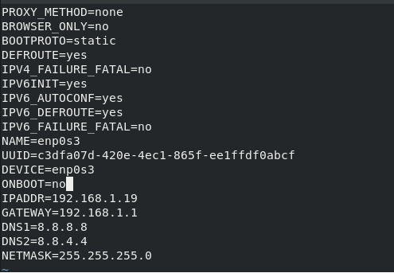

#service network restart